Reference Document

(B2C Casino SPIN GAMES Platform)

Version | Date | Author | Description
1.0 | 13-02-2025 | Allan | Initial draft

Index
- Project Description
- Project Structure
- API Reference
- Server Management
- How to Add New Game

1. Project Description
1.1. Brief Design

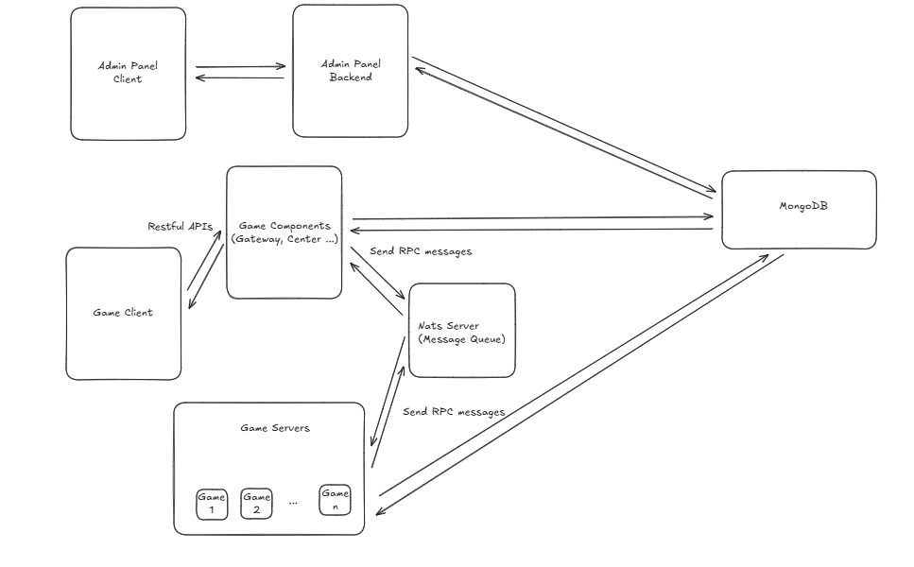
1.2. project description

This project is B2C casino platform supports popular casino games. And project is structed with several components.
- Admin panel
Admin panel manages merchants, line operator, RTP(return to player) control, players, games, and contains other functionalities like analytics dashboard.
- Game panel
Game panel is the collection of games which the players can access and see the list of games.
- Game
Game is cracked version from each popular game platforms(Jili, PG, PP gateway), so it is impossible to check the full source code.
You can see the full version of user manual here
https://user-manual.skyxspin.com/?id=j28dxl&p=loginpage&g=1

2. Project Structure
Source URL: https://github.com/esunna/skyspin

2.1. Game Admin
Game admin panel controls the B2C operation for merchants, line operators, and players, and manages the games.
URL: https://admin.skyxspin.com/
Credential for admin: admin / 123456
Source code: https://github.com/esunna/skyspin/tree/main/gameadmin
This directory contains the game admin backend(golang) and frontend(vue.js)
2.2. Game Components

Game components handle all the services and Restful APIs while game playing
Source code: https://github.com/esunna/skyspin/tree/main/gamecomponents
2.3. Game Servers
Game servers are the collection of each game backend handles RPC call from Game components.
Source code: https://github.com/esunna/skyspin/tree/main/gameservers

3. API Reference
You can see the Postman API collection which simulates the game playing here:
https://github.com/esunna/skyspin/tree/main/documents

4. Server Management
4.1. How to build backend
4.1.1. Admin Backend Build
📌 Process:
- Run gameadmin/backend/buildall.sh to compile the admin backend.
- Copy the generated admin file to /data/backend/ for deployment.

4.1.2. Game Components Build
📌 Process:
- Execute gamecomponents/build.bat to compile all necessary components.
- Copy the compiled files (bin/*) into /data/backend/.
4.1.3. Game Servers Build
📌 Process:
- Execute gameservers/build.bat to build PG (Pocket Games) games.
- Execute gameservers/buildjili.bat for Jili Games.
- Execute gameservers/buildpp.bat for PP (Pragmatic Play) games.
- Copy the generated binaries (bin/*) into /data/backend/.

4.2. How to deploy
4.2.1. Mandatory files:
/data/backend/file.txt
/data/backend/start.sh
/data/backend/launch
4.2.2. Mandatory files:
sh /data/backend/start.sh
4.3. Configuration Files
Caddy Config File - /etc/caddy/Caddyfile
Game UI Built Files - /data/backend/cache
Project Config Files - /data/backend/config
Frontend Server Path - /data/www/
5. How to Add New Game to Spin Platform
- Add new gateway(pggateway) on gamecomponents
- Add new game on gameservers
- Add new game on Admin Panel
- Add new config file on /data/backend/config/{game_id}_setting.yaml
- Update /data/www/game/mock/game.json
- And another things like game built file deploy, and configure
6. How to Integrate Playstar(External) Game to Spin Platform

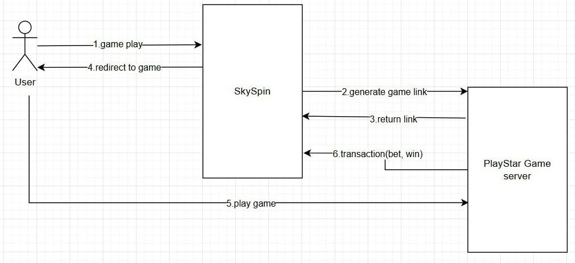

- config/grpc_route.yaml
externalapi: :11201
externalapi.http: :11200

- config/game_config.yaml
externallaunchurl: https://server.xoioplay.com/api/v1/game/launch
- config/demoGame.json
- file.txt
externalapi
- start.sh
supervisorctl start externalapi

